**Experiences and learning in CCCM**

Application form

**Dear Contributors,**

Thank you very much for sharing your experience and learning in CCCM with the CCCM community as well as the wider humanitarian community.

This year’s case studies collection covers projects developed, in progress and/or been evaluated during 2020 – 2021 and focuses on 5 main topics:

* Climate change and disaster preparedness
* Camp Management updates
  + all CM modalities are included e.g.: SMS, mobile, area-based, etc.
* Working with state & non-state actors
* Localisation

Site environment & inclusion

cross-sectorial case study submissions are highly encouraged for this topic

**Submission deadline: 14th of January 2022**

After the submission deadline we will contact you to discuss the case study, additional information needed and timeline to draft the final document. All completed case studies are shared with the authors for approval. After the final review and approval for publication given by the Global CCCM Cluster SAG, all case studies are published on the Global CCCM website. Please see previous case studies collection as sample:

<https://cccmcluster.org/index.php/resources/cccm-case-studies-2020>

To allow adequate space for reflective documentation and lessons learned, case studies will not be directly attributed to individuals or organizations. However, credits to individuals and organizations will be provide in the general acknowledgments section with your consent.

Tips for drafting your case study:

* Please help us by sticking to word limit of each section as much as you can.
* This form can be filled out in bullet point format. We are happy to assist with the drafting of the case study.
* Please avoid writing an ‘overview’ style of document – that is, a case study that covers lots of aspects but in little detail. It is generally more useful for the readers if you write in more depth and focus on a small number of aspects of your project.
* Please avoid a long introduction on the background/scope of the overall project. This takes up space that you could be using to provide useful analysis of the CCCM activities you are covering.
* Please avoid writing in an overly descriptive style. You may need to describe a situation to set the context, but the main substance of the case study should be focused on the specific CCCM activities and the learnings – if possible include examples of any poor/good practice, recommendations, challenges remaining, lessons learned, etc.
* It is useful to write in a way that makes the case study useful for other CCCM practitioners working in different countries/regions.

Please email completed form, supporting documents and photos to: [casestudies@cccmcluster.org](mailto:casestudies@cccmcluster.org)

**For any questions/queries and/or assistance with collating case study information please reach out to:** [**agrafweg@iom.int**](mailto:agrafweg@iom.int)

# **Word limit: 1500 words**

# **1. Contact information**

### Person(s) completing this form:

|  |  |  |  |
| --- | --- | --- | --- |
| Name: |  | Organization: |  |
| Email: |  | Skype/WhatsApp: |  |

|  |  |  |  |
| --- | --- | --- | --- |
| Name: |  | Organization: |  |
| Email: |  | Skype/WhatsApp: |  |

# **2. Data sources**

### Individuals who should be credited in the acknowledgments section of the document:

*Please include the name, organisation and email address of each person who has made a significant contribution to the compilation of this case study.*

|  |  |  |  |
| --- | --- | --- | --- |
|  | Name | Email | Notes: |
| 1 |  |  |  |
| 2 |  |  |  |
| 3 |  |  |  |

**Supporting Documents:** These can be both public and confidential documents (project strategies, maps and diagrams, assessment analysis, information sheets, reports, training outlines, camp management checklists, etc. )

For files above 4MB, please use WeTransfer <https://www.wetransfer.com/>

**Photographs:**

* Copyright for photographs must allow for free use for the purposes of this publication.
* Please send photos of min 500Kb for quality assurance when printing.

Please provide photo credit information:

|  |  |  |  |
| --- | --- | --- | --- |
| File Name | Credit | Contact | Caption or short description |
|  |  |  |  |
|  |  |  |  |
|  |  |  |  |
|  |  |  |  |
|  |  |  |  |

# **3. Key project information**

*Please disregard fields not applicable for your case study*

|  |  |  |  |
| --- | --- | --- | --- |
| Main chapter topic: |  | | |
| Theme of experience/learning: (please give a title) |  | | |
| Location: |  | | |
| Date of event: |  | | |
| Total no. of people displaced:(if known) |  | | |
| Total no. of people targeted by the project: |  | Beneficiaries Targeting: (IDPs, Refugees, host communities, etc.) |  |
| Project location:(Country, State/Province, District/County, and City/Village): |  | | |
| Project Start Date: |  | Project End Date: |  |
| Project Duration: |  | | |
| CCCM coordination mechanism:(national and sub-national) |  | | |
| Support cost per household: (if known) |  | | |
| Project cost per individual: (if known) |  | | |

**Please provide supporting data and information as links or footnote where relevant.**

# **4. PROJECT SUMMARY**

In 2 or 3 sentences, please give a summary of the case study and describe how this project showcases the theme(s) being discussed in the chapter.

|  |
| --- |
|  |

# **5. challenges lessons learned (approx. 300 words)**

Please share key challenges and lessons learned of the project. (This section is the most read component.)

|  |
| --- |
| Challenges & Shortcomings: (max 5 bullet points): *What were the key obstacles, bottlenecks and barriers experienced?* |
| * . * . * . * . * . |
| Lessons Learned & Recommendations (max 5 bullet points): *What were the key learning, recommendations and suggestions?* |
| * . * . * . * . |
| Lessons Learned & Recommendations - How were the Minimum Standards in Camp Management utilised in the project? (max 3 bullet points): *Please give details on the specific CM standard and the application.*   * . * . * . |

# **6. Context**

*Please describe crisis and/or country context:* (*max. 200-300 words*) *Alternatively, please provide reference documents describing crisis and/or country context)*

|  |
| --- |
|  |

# **7 PROJECT OBJECTIVES**

### *How did the project aim to respond to the crisis or situations?* (3 sentences approx. 100 words)

|  |
| --- |
|  |

# **8. PROJECT Timeline**

*Please provide key project milestones. Alternatively, this can be discussed later in person (online discussion):*

|  |  |  |
| --- | --- | --- |
|  | Date | Event |
| Milestone 1: |  |  |
| Milestone 2: |  |  |
| Milestone 3: |  |  |
| Milestone 4: |  |  |

# **9. Project DETAILS** (approx. 1000 words)

*Please share a summary of how the project was implemented. We have placed here some prompts you may consider including in your description’s heading.*

|  |
| --- |
| **Geographical targeting and selection of beneficiaries:**  **CCCM activities:**  *(what was specific about the CCCM activities regarding the CM approach and context?)* Protection risks:(what were the issues/challenges and how did this project address them?) **Engagement with/impact of coordination mechanism:**  **How were the** [Minimum Standards in Camp Management](https://cccmcluster.org/resources/minimum-standards-camp-management) **utilised in the program?**  (also see recommendation & lesson learned part) |
| **Key Project Achievements:** |

# **10. Quotes** from beneficiaries/project staff/authorities, etc.

Include here any short quotes to liven up the text/contribute to accountability to affected populations. Alternatively, please suggest topic of short, recorded interviews with key program stakeholders to accompany the written case study. (local language a possibility)

|  |
| --- |
|  |

Please indicate if you are willing to participate in a short interview recording of the case study:

Yes No more information

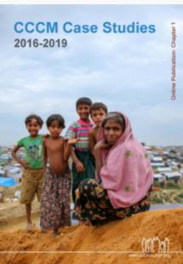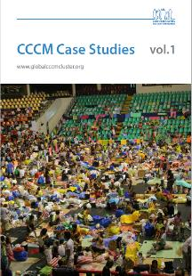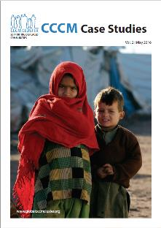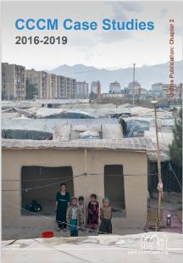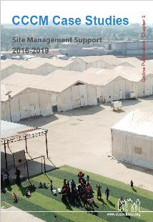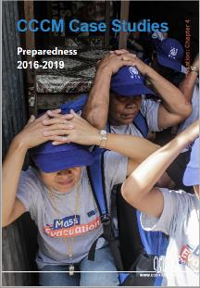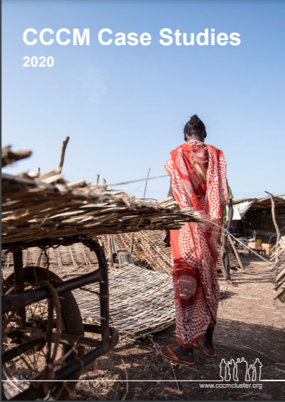

<https://cccmcluster.org/index.php/resources/cccm-case-studies-2020>

**THANK YOU VERY MUCH FOR YOUR CONTRIBUTIONS!**