# ABA WG Reference group -ABA online repository

# Meeting 1 – 18.11.2021

# Meeting Summary

Reference group:

Thomas Stork (DRC), Petra Petrova (DRC), Mathilde LIGNEAU (ACTED), Amelia SAVELL-BOSS (ACTED), Ellie GOLDNEY (ACTED), Henry Orji (NRC), Shadan Namiq (NRC), Nameer Osama Abdulqader (NRC), Pierre-Claver Nyandwi (UNHCR), Walid Al-Hashedy (UNHCR), John Macharia (UNHCR), Veronica Adele COSTARELLI (IOM), Mahmud Naief (IOM), Adam James (IOM)

Attendance:

Thomas Stork (DRC), Mathilde LIGNEAU (ACTED), Ellie GOLDNEY (ACTED), Henry Orji (NRC), Nameer Osama Abdulqader (NRC), Walid Al-Hashedy (UNHCR), Adam James (IOM)

Facilitators: Giovanna Federici (NRC), Annika Grafweg (IOM)

Documents shared: Meeting Agenda, Miroboard [HERE](https://miro.com/app/board/o9J_lVYrcxw=/) , Access to Share folder for reference group – please see e-mail.

**Agenda**

**CCCM ABA working group**

**1st reference group meeting- 18-11-21**

|  |
| --- |
| Welcome & Introduction |
| Background & What is the reference group? |
| 1. Understanding the problem |
| Working in pairs @2:  *Miro board:*   1. *Where do you look, when you need advice, tools, guidance for ABA?* 2. *What do you look for?* 3. *Who do you speak to?* 4. *How do you search?* |
| Plenary discussion |
| 1. “Stocktaking” |
| Working in pairs @2:  Guiding questions:  *Q: Which of this information do you already know?*  *Q: Is this useful information that should be included?*  *Q: Add documents that should be included?*  *Q: any other comments* |
| 1. “Starburst” brainstorming |
| Working in group @3:   * Miro board |
| Plenary discussion |
| Conclusion |
|  |

|  |  |  |
| --- | --- | --- |
| **Agenda** | **Discussion** | **Action Point** |
| 1. Welcome & Introduction | Brief introduction of all present in the 1st ABA reference group call. See attendance above |  |
| 1. Background | Giovanna presented a brief background on the activities of the ABA working group. More info on CCCM ABA WG website: [Area-based Approach Working Group | CCCM Cluster](https://cccmcluster.org/global/Area-based-Approach-Working-Group)  The scope of the ABB WG reference group is focused on developing the content and structure for an area-based online repository within the global CCCM Cluster website. It will collate area-based related documents, tools and guidance and structure them under thematic headings relevant to CCCM practitioners.  The 1st meeting was a brainstorming meeting to take stock of existing documents, tools and guidance on area-based related topics (see share folder) and explore the structure, thematic topics and content to be included in the online repository.  There will be a total of 3 Reference group meetings in the next 8 months, with the aim to present the final aba repository at the annual global CCCM retreat 2022:   * 2nd meeting:  End of January (exact date TBC). - Review of  1st proposal * 3rd meeting: End of April (exact date TBC). - Final review of draft aba repository. |  |
| 1. ‘Understanding the problem’ | The 1st exercise focused on working in pairs on the group’s interactive miro board to explore the following questions as well as challenges when searching for aba guidance, documents and tools.  Questions:   1. Where do you look, when you need advice, tools, guidance for ABA? 2. What do you look for? 3. Who do you speak to? 4. How do you search?   See Miroboard snapshot below for details  Feedback summary:   * Formal & informal networks of CCCM practitioners and other sectors are consulted with experience in aba programming- preferably in the local context * Case studies with exact examples, lessons learned, and best practices are searched * Most useful are tools, templates (for implementation) and context specific legal guidance (HLP, governmental frameworks) * NRC CCT toolbox, case study collection (CCCM/Shelter) and national/regional development plans are being consulted |  |
| 1. ‘Stocktaking’ | Link to share folder shared. All content that will be added to the online repository are inside thematic folders. The folder is accessible to all reference group members throughout the process.  Link to share folder in e-mail as restricted access for reference group only  All reference group members are asked to upload ABA relevant documents to the folder incl.:   * local/ reginal or national documents * Agency level tools, Templates, guidance * All languages | **Please view existing documents in share folder.**  **Gathering of documents to be included**  **All reference group members to add relevant documents to the folder.** |
| 1. ‘Starburst brainstorming’ exercise | See snapshot of starburst outcome of Miro board below.  Key discussion focused on the **thematic areas** that will structure the documents:  - Thematic areas to be divided in core & specific thematic areas  - Structured by phase of project cycle & tools to be included for different phase of response (focus on implementation)  - searchable by country/ region (ideally hosting contextualized examples for tools/templates)  - geographic/ administrative scales (neighborhood/ district/city/ regional/national)  - thematic area proposed: HLP, GBV, Participation, Community centres, | **All reference group members to add comments on thematic areas to miro board**  **Add thematic areas** |
| 1. Conclusion & next steps | Next reference group meeting to focus on the thematic areas that will structure the online repository.  **2nd meeting: end of January- details to follow** |  |

**Stocktaking excerise:**

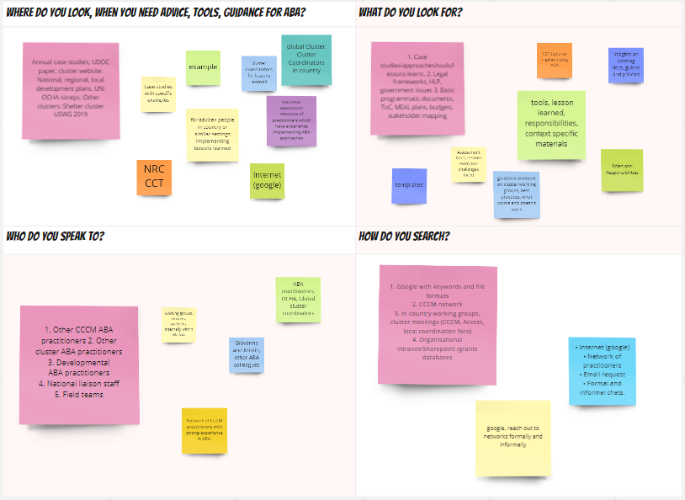

**Starburst diagram: for detail please go to miro board:**

