Minutes: Capacity Development WG- 10.12.2019
Attendance: Elena (ACTED Somalia, chair), Jennifer (IOM, Global), Jørn (NRC, global), Kate (DRC Iraq), Fardowsa (ACTED South Sudan), Stamatia (South Sudan CCCM cluster), Kathryn (DRC Bangladesh), Frank (IOM Iraq)
Agenda | Discussion | Action Point
- Updates on the FAQ for the training registry | Based on previous WG discussion, Elena and Jennifer worked on a FAQ document to promote the training registry. The FAQ PPT was presented and reviewed with partners.  Kate requests the chair to include in the FAQ a slide on “what to upload/what not to upload” to ensure that the training that are registered remained pertinent to CCCM and/or CCCM cross-cutting issues (for example: no excel training). Kate also comments that it would be valuable to have a more narrative version of the FAQ to accompany the power point.  Elena proposes the idea of the FAQ video, as a more interactive way to engage with viewers and attract their attention on the registry. She proposes to prepare a pilot video, for partners to review/endorse. | Elena to update the FAQ as per partners inputs  CD WG to work on a narrative version of FAQ/Training registry Guidelines  Elena to prepare an pilot FAQ video
- Review of draft work-plan for 2020 | The chair presented the draft work-plan for 2020. The capacity development working group hosted a breakout session during the CCCM Global cluster retreat in October 2019. The discussion was translated into different action points/recommendations for the capacity development working group to address in the coming year. The capacity building working group also held a meeting on 6th November 2019, to further debrief on the discussion with participants who were not at the treat and develop action points and brainstorm on activities and priorities for 2020. Based on these different discussions, 2020 work-plan was drafted to guide the working group activities in 2020.  The work-plan had 3 main objectives: 1. Promotion of the Capacity Development WG and creation of a Community of Practice 2. Promote dissemination of tools, methods and approaches among trainers and among countries operations. 3 Impact Evaluation, fundraising and skill development  As per the draft work-plan, in the first half of 2020 (January to June) the working group will primarily focus on promoting an inclusive membership, and participation from National clusters, promoting the CCCM Global Package and promoting exchange of tools among trainers (objective and 2), whereas in the second half of the year the working group will conduct an impact evaluation and turn its focus to fundraising based on the findings from the evaluation (objective 3).  Partners` comments, questions and feedback on the draft work-plan:  - How would the community of practice look like and what would be National Cluster CD Focal Points? The National Cluster CD Focal point would act as a link between the national cluster responses and the WG, and ensure that the views and needs of national needs are reflected in the WG discussions. They would also support partners and contextualization processes in their own countries responses. Their contact details could be included in the website with their agreement  - The work-plan should more clearly focused on understand and explore cross sectorial learning opportunity/material and on how to keep the training package flexible, with possibility to add specific modules on topics that are interlinked with camp management (for example CT, sustainable settlements)  - The partners highlight the need to keep the new/cross-cutting topic harmonized with (and organized according to) the different tags of the training material  - Jennifer shares with the members that at the moment methodology for case study collection is currently being reviewed. The case study will be more cross-sector focused: if the partners have critical topic they would like to be included in the case study collection should flag it with the working group  - Mention in the work-plan role of the CCCM Cluster and where the WG would need to be supported by the CCCM global cluster  - Add for every activity what specific support the WG will require from the partners. The work-plan could be accompanied by a matrix where partners could directly volunteers for the activity/tasks they would be more involved in  Elena to update the work-plan to incorporate partners` feedback and then re-circulate the work-plan for endorsement.  Once endorsed the work-plan will be presented to the SAG members. SAG might request a presentation in February: members who would be willing to support the presentation of the Work-Plan should share their interest with the chair. | Elena to review the draft work-plan, incorporate partners` feedback and re-circulate for endorsement  Volunteers for presenting the work-plan in front of the SAG to write their interest to the chair  Partners to flag to the working group any critical topic they would like to be included in the case study collection
- AOB | It is now possible to filter CCCM related trainings and articles on relief-web: you just need to select “Camp Coordination and Camp Management” filter under the section “Theme” in the “Filter Results” box. Brian will link Relief web “CCCM” filtered results directly on the CCCM global cluster website.  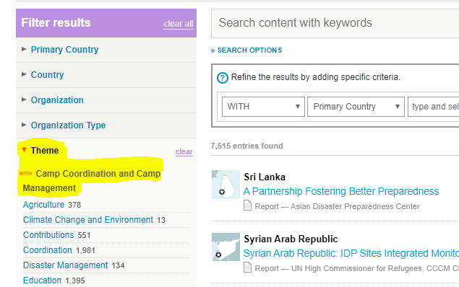  Following the hurricane that hit Bahamas a CCCM training is currently on-going.  For January, the publication of a CCCM Capacity building news article to on the website is planned: partners who have recently conducted trainings and would like to share their experience should get in touch with the working group. Partners note it would be good to have more than one training featured in the article as well as ensure representation of different geographical areas. Partners also note some recent capacity building events that could be included in the article happens in Bangladesh, Bahamas, Ethiopia and Somalia. Jorn highlights that the article should include also a brief countries overview. | Partners interested in sharing recent training for the article to get in touch with Elena, Brian and Jennifer

#

